Capstone Project

Selecting the best option to open a Sushi Bar in Manhattan, New York.

The Battle of Neighborhoods’

Introduction

The City of New York is famous for its excellent cuisine. Its food culture includes an array of international cuisines influenced by the city's immigrant history.

Sushi bars have become so popular in the United States, now it seems that there is one on every corner, not only in major cities but also in smaller cities. Starting a Sushi bar can be a great business opportunity, but you need to distinguish yourself from others to enjoy long-term success.

Business Problem

I want to open my business in Manhattan area, keeping in view, I define potential neighbourhood based on the number of Sushi bars which are operating right in each neighbourhood. Manhattan has full potential but also is a very challenging district to open a business because of high competition. New Sushi bar should be open in an area that inadequate neighbourhood in this way my Sushi bar can attract more customers. Therefore, this analysis is necessary to ensure that we will have enough customers and that we will not so close to other Sushi bars.

# Data Section

Data Selection

* To identify the characteristics of our competitors' venues in Manhattan, we would first need to find out the number of Sushi bars in Manhattan currently and their location.
* We then used Google Map API to find their geographic coordinates based on their postal code addresses.
* In Manhattan, there are 1763 Sushi bars are currently operating.
* <https://geo.nyu.edu/catalog/nyu_2451_34572> (1763, 7)
* Next, we also used Google Map API to find their geographic coordinates of the 5 locations shortlisted for our Sushi bar;

Methodology

* Addresses are converted into their equivalent latitude and longitude values.
* Foursquare API is used to explore neighbourhoods' in Manhattan, New York.
* A screenshot of a cell phone

  Description automatically generatedAfter that, explore function to get Sushi bar categories in each neighbourhood.

Table 3: Data frame containing counts of neighborhood.

* Sushi bars in Manhattan

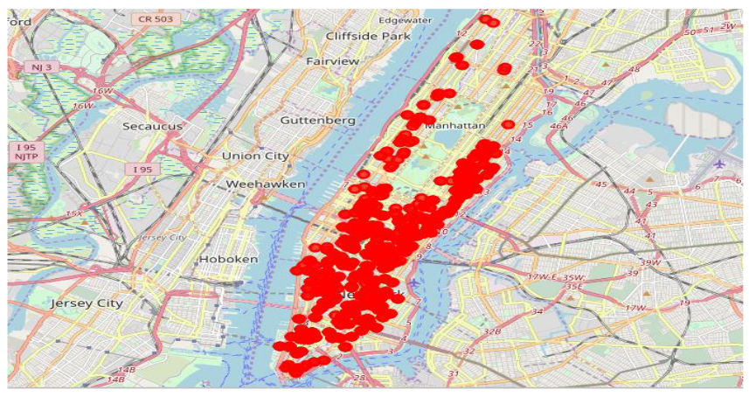

* Then using this feature to group the neighbourhoods into clusters K-means clustering algorithm will be used to complete this task. And also, the Folium library to visualize the neighbourhoods’ in Manhattan and its emerging clusters.

Results

* Using K-mean to clustering data area with less number of Sushi bars;

Cluster 1

Cluster 2

Cluster 3

Cluster 4

Discussion

* This analysis is performed on limited data, results may vary. But if good amount of data is available there is opportunity to get better results.
* There is high competition in Midtown and Sohoso it is very risky to open business in these areas.
* Central Harlem has also potential where closes to Morning side Heights area.
* More detailed analysis is suggested by adding other factors such as transportation, demographics of inhabitants, etc.

Conclusion

* Although all of the goals of this project are met, there is definitely opportunity for further improvement.
* Apart, goals of the project, this can easily be extended into a fully functional application that could support the entrepreneurs’ in opening a new business in an unknown location.